## Project Report Template

## Introduction:

A visa is a document that is stamped on a persons passport by an embassy. It names the kind of visit and says how long the person can stay. Sometimes, people need to go through an interview held at the embassy before they get a visa. Many countries require foreign visitors to have a valid passport and a visa before they can enter the country, but there are exceptions.

Some countries, such as some states of the former Soviet Union, require that their citizens, and sometimes foreign travelers, obtain an exit visa in order to be allowed to leave the country. Until 2004, foreign students in Russia were issued only an entry visa on being accepted to University there, and had to obtain an exit visa to return home. This policy has since been changed, and foreign students are now issued multiple(and exit) visa.

**Problem Definition and Design Thinking:**

**Empathy map:**

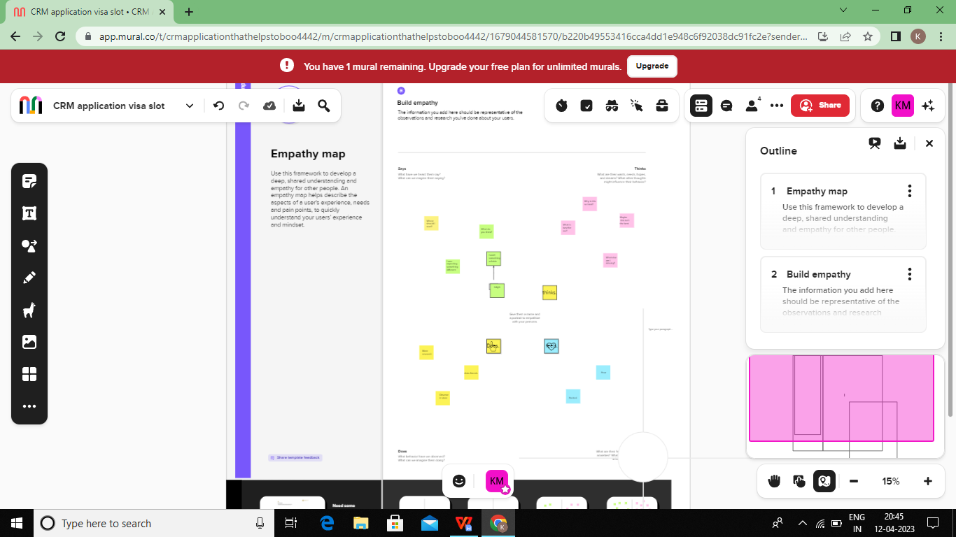

**Idealization and Brainstorming map Screenshot:**

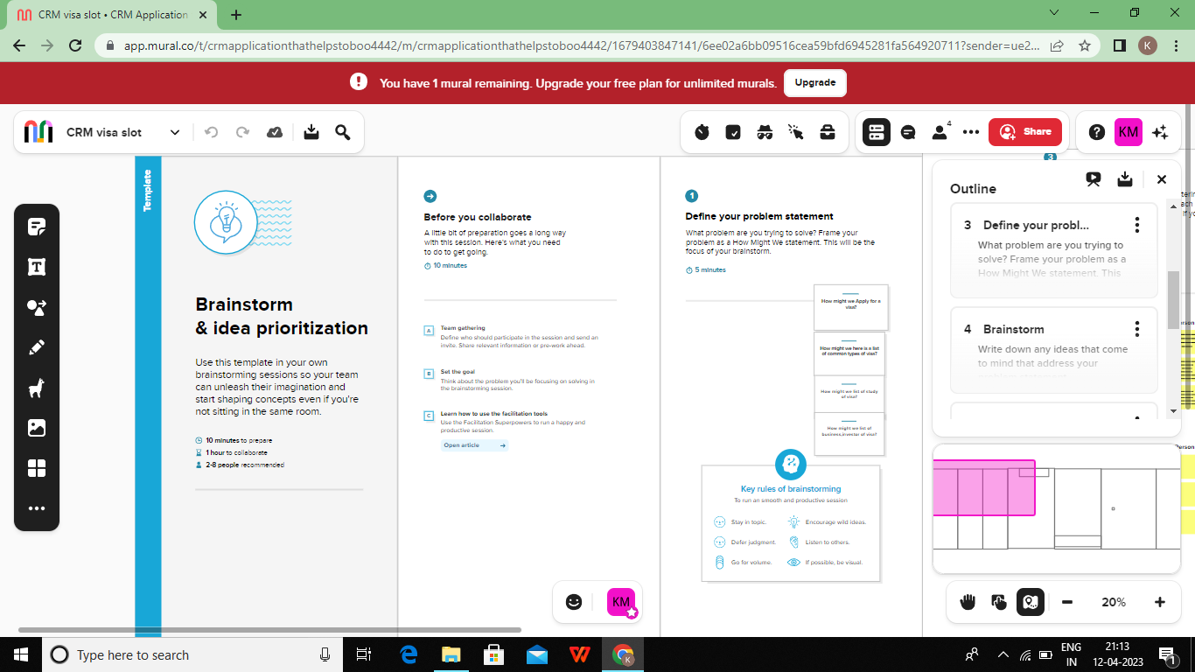

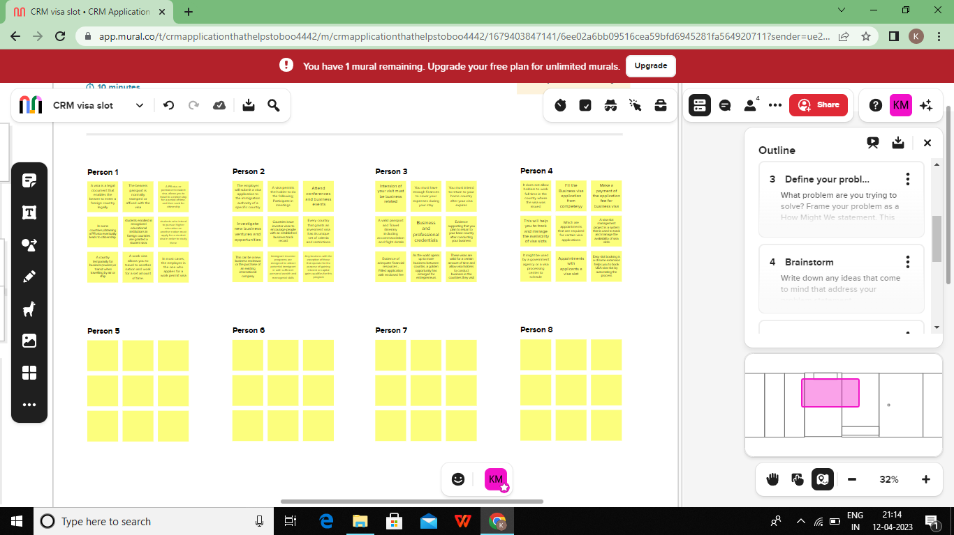

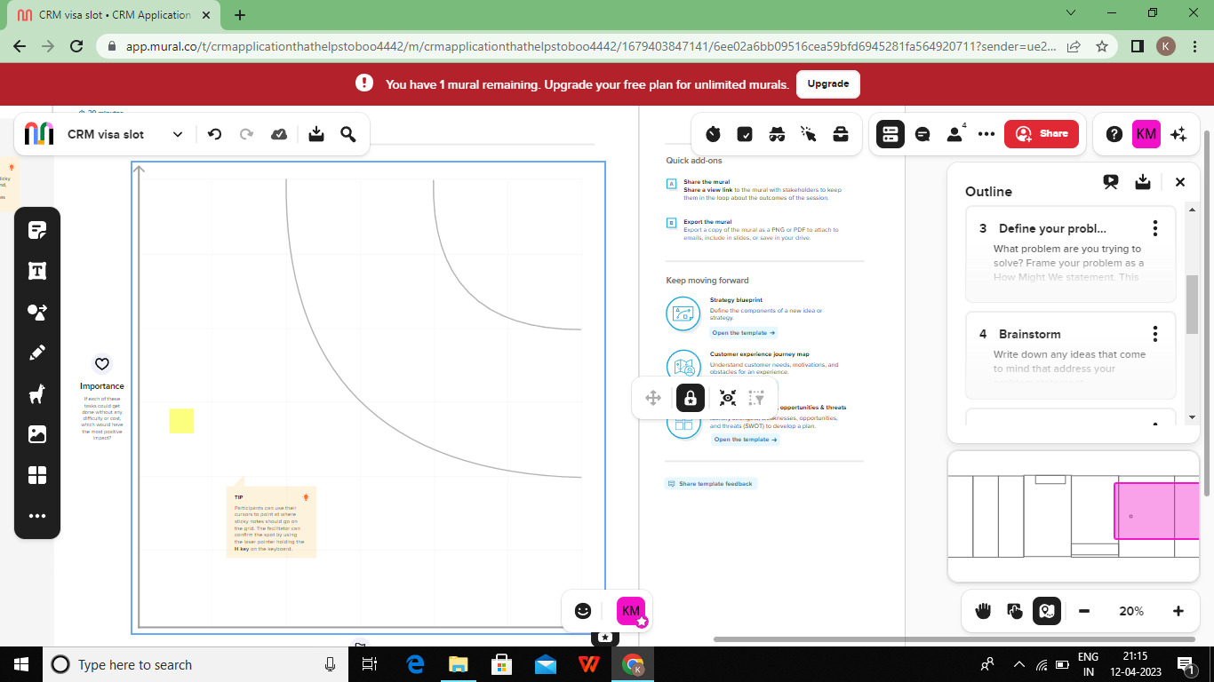

**RESULT:**

**Activity and screenshot:**

**Create Salesforce Org-creating Developer Account**

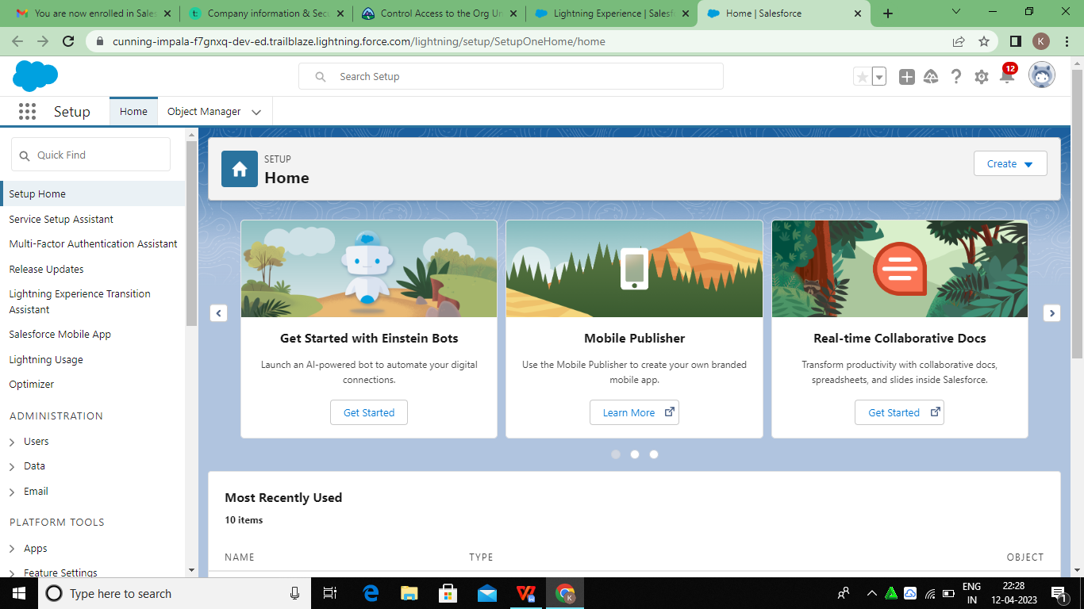

**Creation of offer object:**

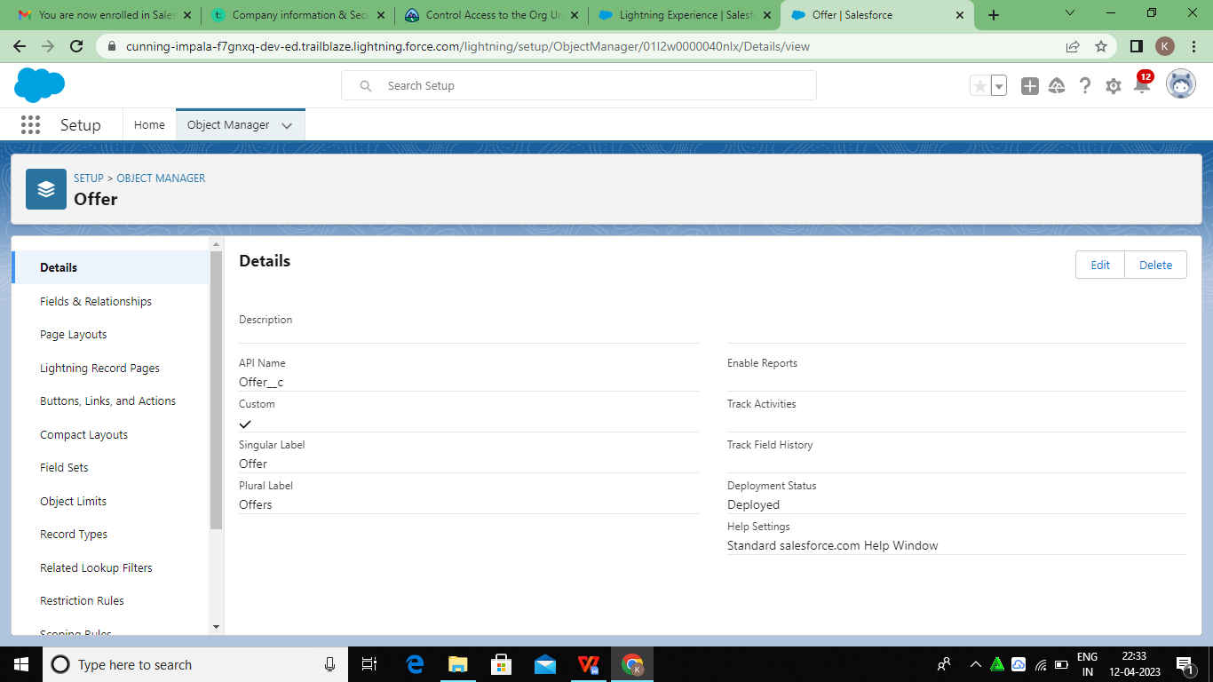

**Creation of Energy Audit Object:**

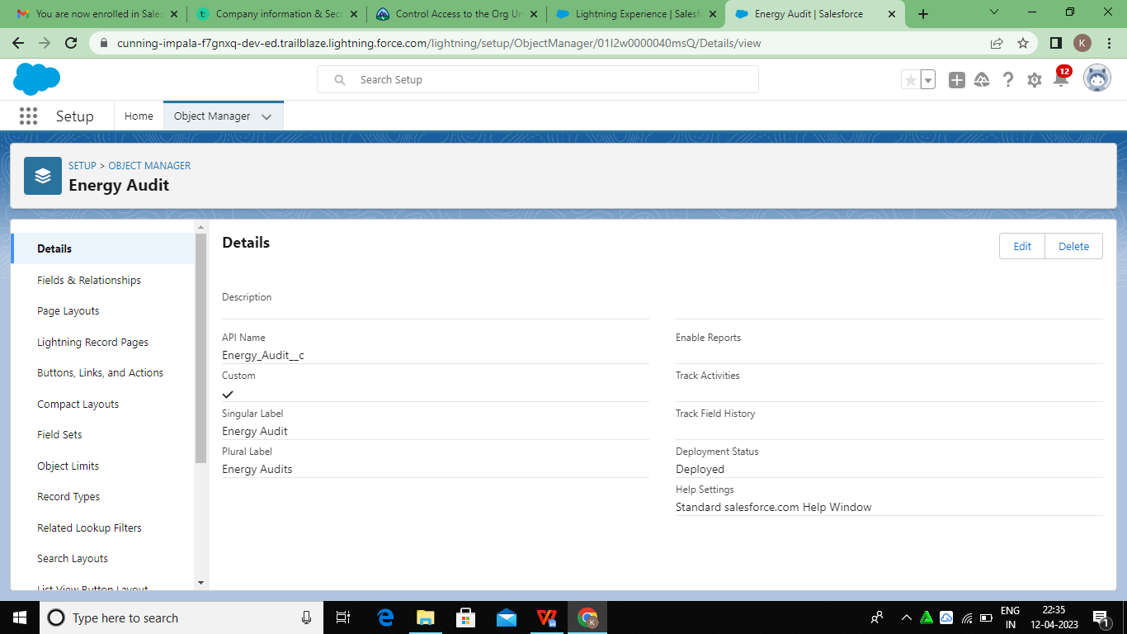

**Creation of project object:**

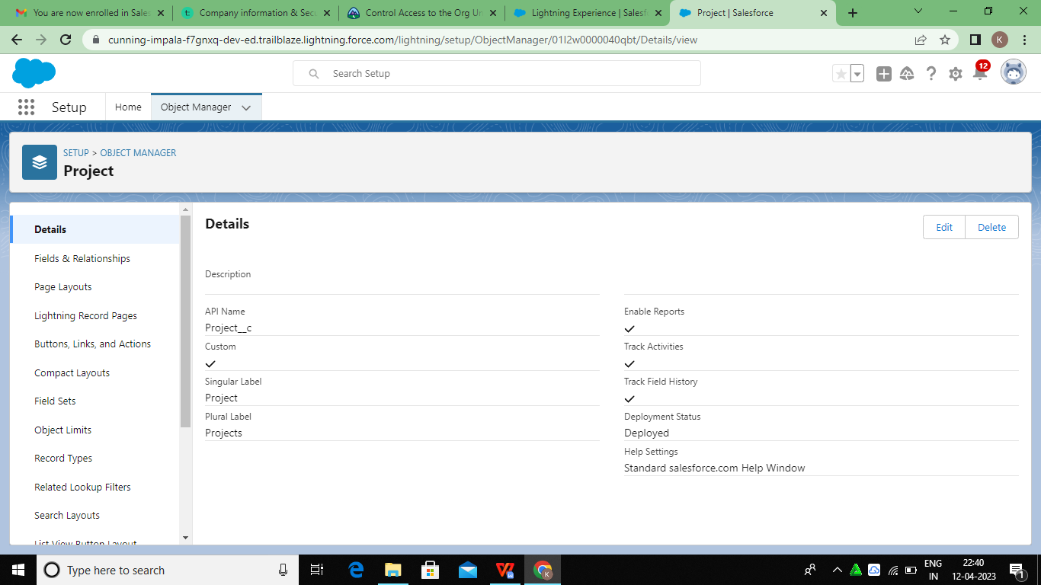

**Lightening App**

**Create sales app**

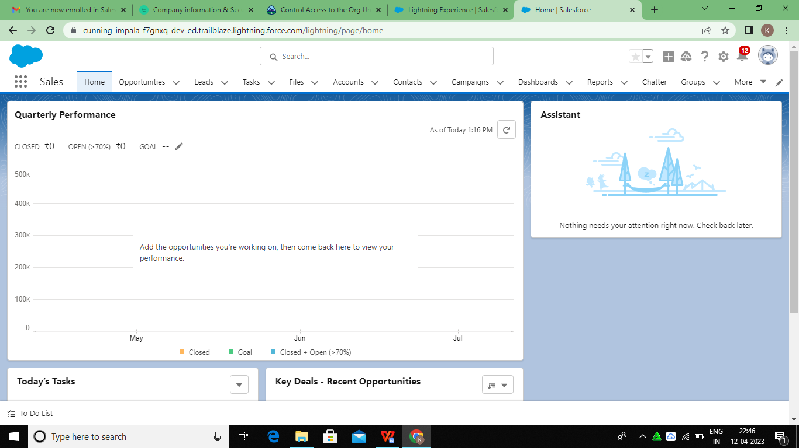

**Fields and Relationship**

**Creation Field for The Energy audit**

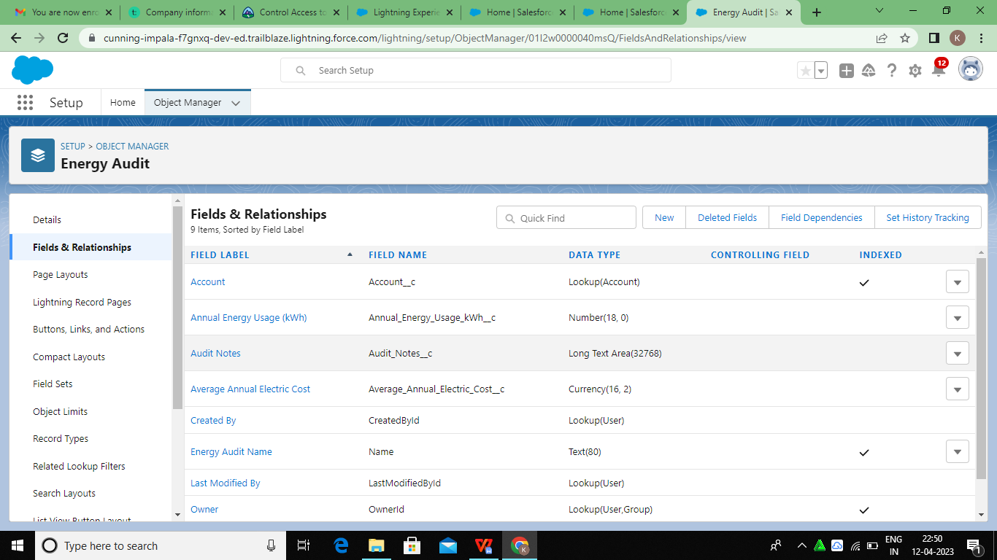

**Creation of Fields for offer**

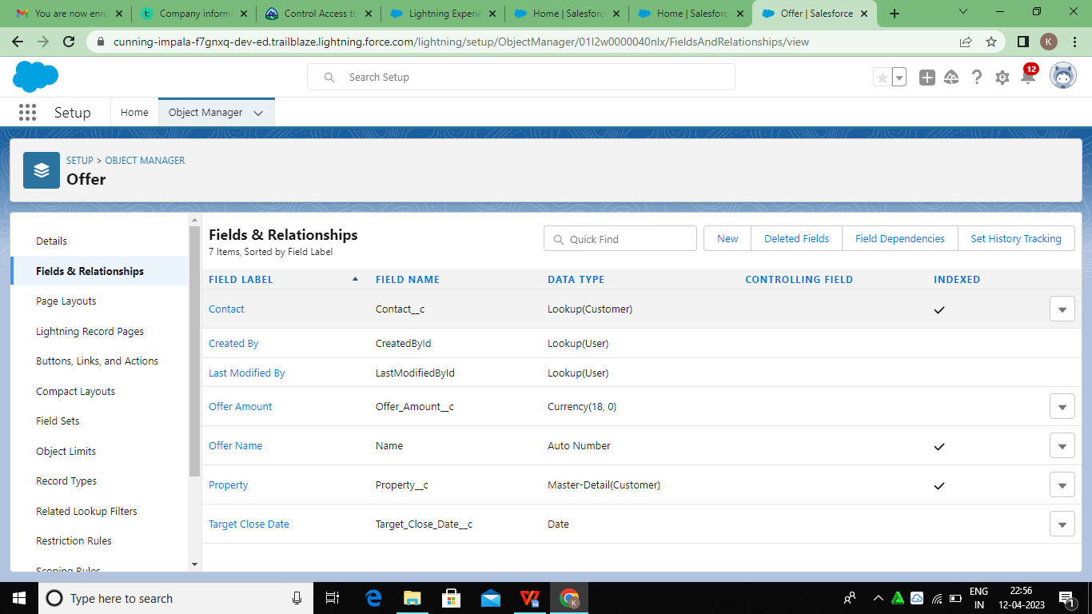

**Creation of Fields for project**

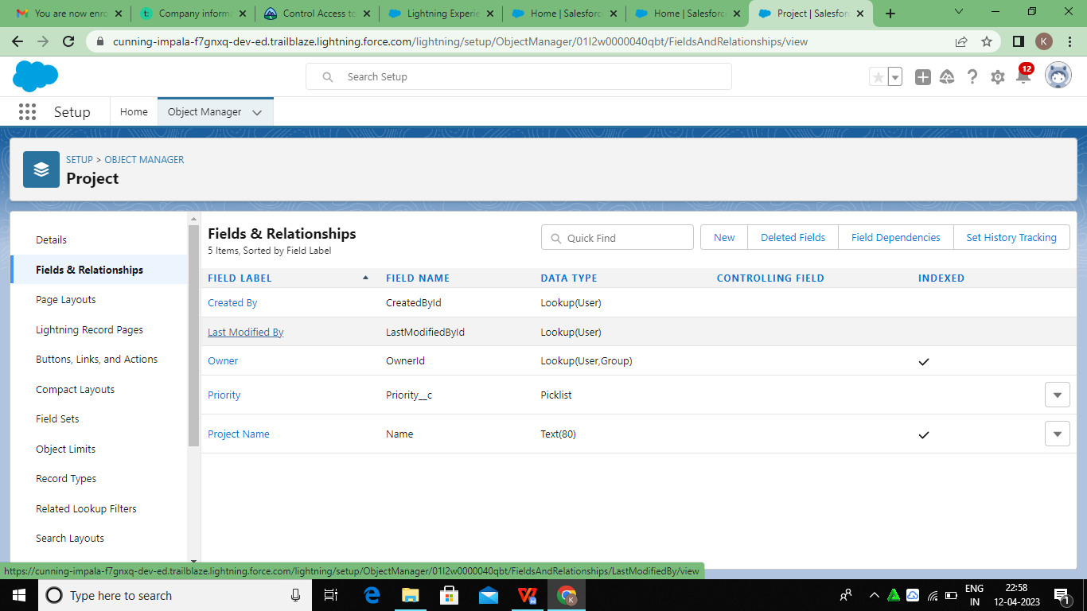

**Profile**

**Creation of profile**

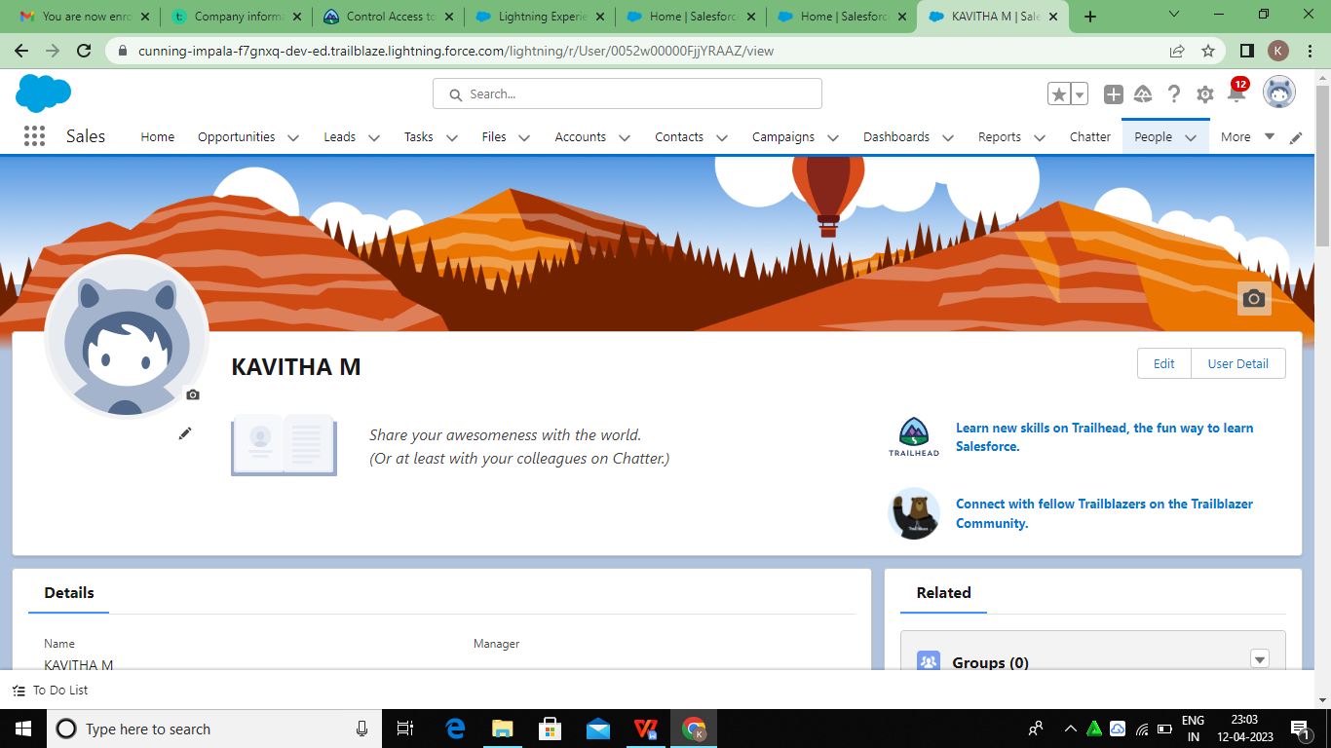

**Users**

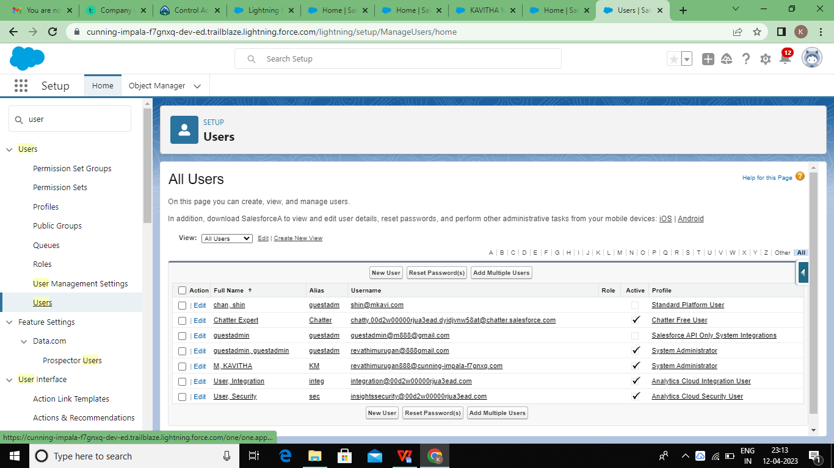

**Permission Sets**

**Permission 1**

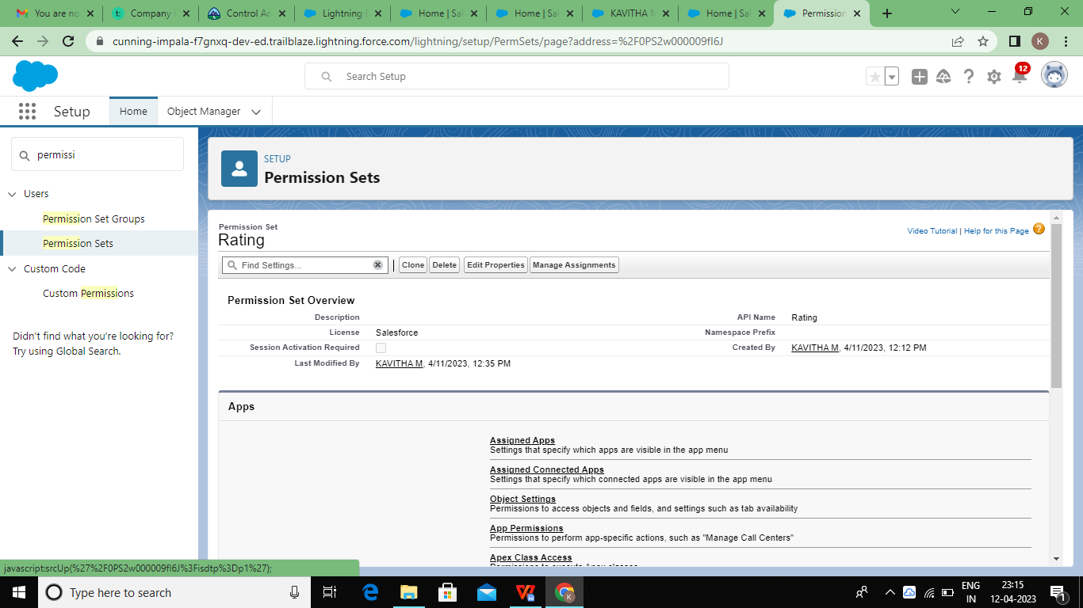

**Permission 2**

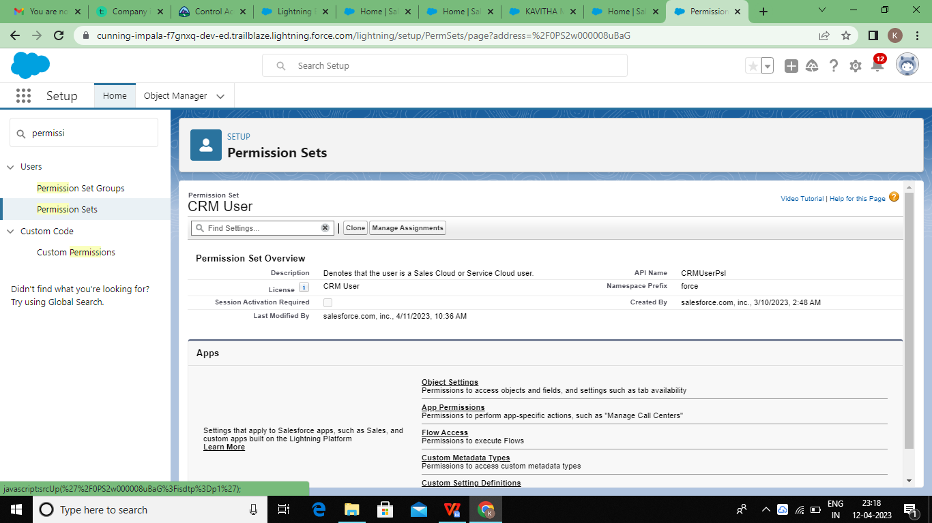

**Reports**

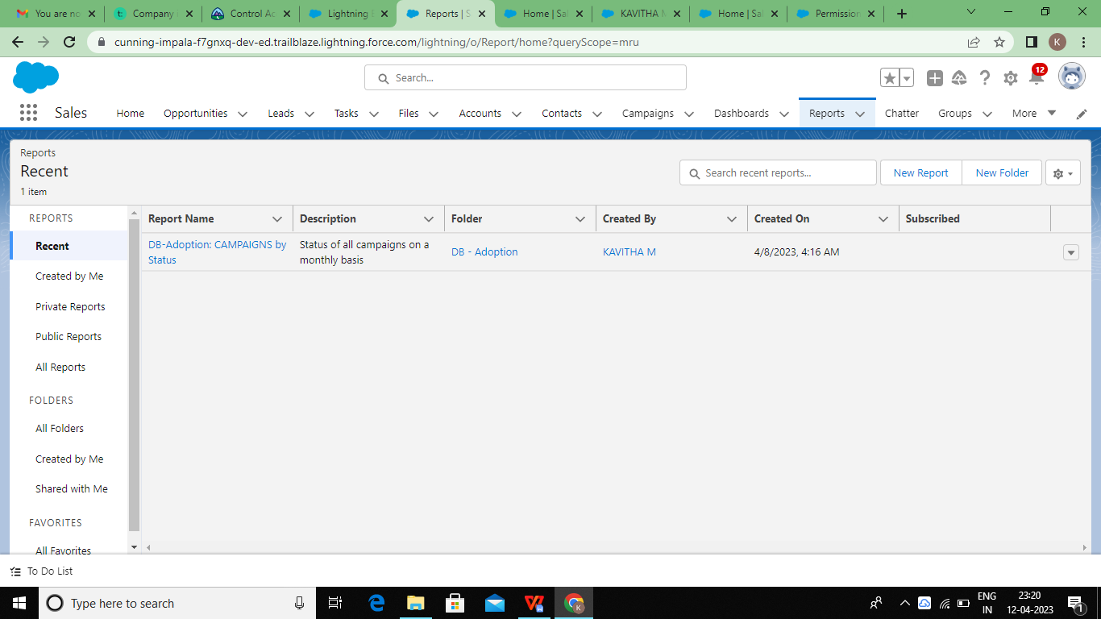

**Trail head Profile public URL:**

**Team lead- <https://trilblazer.me/id/kavem3>**

**Team member 1- <https://trailblazer.me/id/nathi123456>**

**Team member 2- <https://trailblazer.me/id/mujii1>**

**Team member 3- <https://trailblazer.me/id/nagalakshmi143>**

**ADVANTAGES&DISADVANTAGES**.

* Trustworthy reporting
* Dashboards that visually showcase data.
* Improved messaging with automation.
* Proactive service.
* Efficiency enhanced by automation.
* Simplified collaboration.
* Sourcing Organic Leads
* Launch Email Campaigns
* Improve Team Coordination
* Generate Reports
* Market Research Data
* Task and Time Management
* Provide Better Customer Service
* Access Sales and Customer Data Instantly.
* CRM costs. One of the greatest challenges to CRM implementation is cost
* Business culture. A lack of commitment or resistance to cultural change from people within the company can cause major difficulties with CRM implementation
* Poor communication
* Lack of leadership.

What is one of the main advantages of CRM?

A CRM can help you store customer data such as user behavior, how long a customer has been with your business, purchase records, and notes on sales interactions, which you can use to optimize your sales and marketing processes and improve customer service across your organization.21-Feb-2023

What is not the advantage of CRM?



Certain businesses where customer transactions are highly standard may not benefit from a CRM system. A CRM system works best where personalisation is required in client/company interactions and where there are multiple touch-points over time between the client and the business across departments.

**APPLICATION:**

How to write a visa application

**Required Details For Business Purposes**

1. Letterhead of company.
2. Travel dates.
3. The purpose of the business trip.
4. The duration of the trip.
5. The company name, as well as your position in the company.
6. The visa type you are applying for (Business Visa)
7. Contact information of the employer.
8. Any other relevant information

**CONCLUSION:**

CRM is developing into a ma+or element of corporate strategy for many organizations. A greater focus on CRM is the only way the banking industry can protect its market share and boost growth. with intensifying competition, declining market share, deregulation, smarter and more demanding customers, there is competition between the banks to attain a competitive advantage over one another or for sustaining the survival in competition.-n -India, the banking sector has been operating in a very stable environment from last thirty forty years.